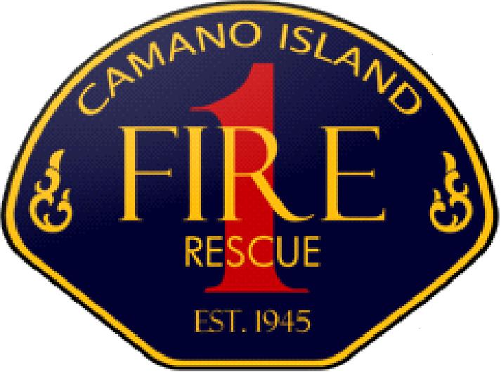 | 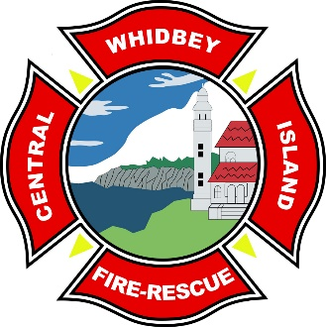 | 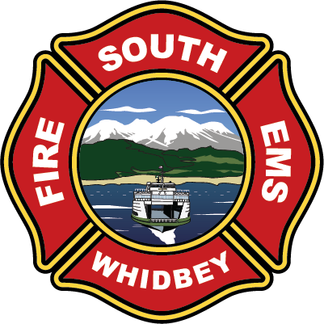 | 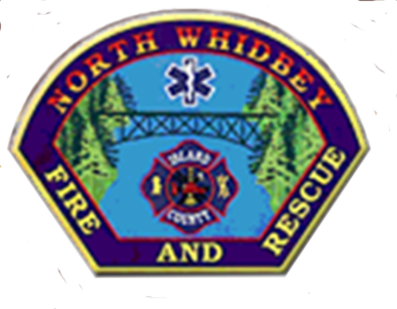

ISLAND COUNTY BOARD OF FIRE COMMISSIONERS MEETING AGENDA
Wednesday, November 6, 2024 at 5:30 PM 1164 Race Rd., Coupeville WA 98239

Join Zoom Meeting
https://us02web.zoom.us/j/89342056699

Pledge of Allegiance
Consensus Approval of the Agenda
Introductions
Topics of Discussion
- Housing
- Permit Process
- Whidbey Health
- Fire Marshall
Contact List
Good of the Order

