2025

SWFE

TRAINING

PLAN

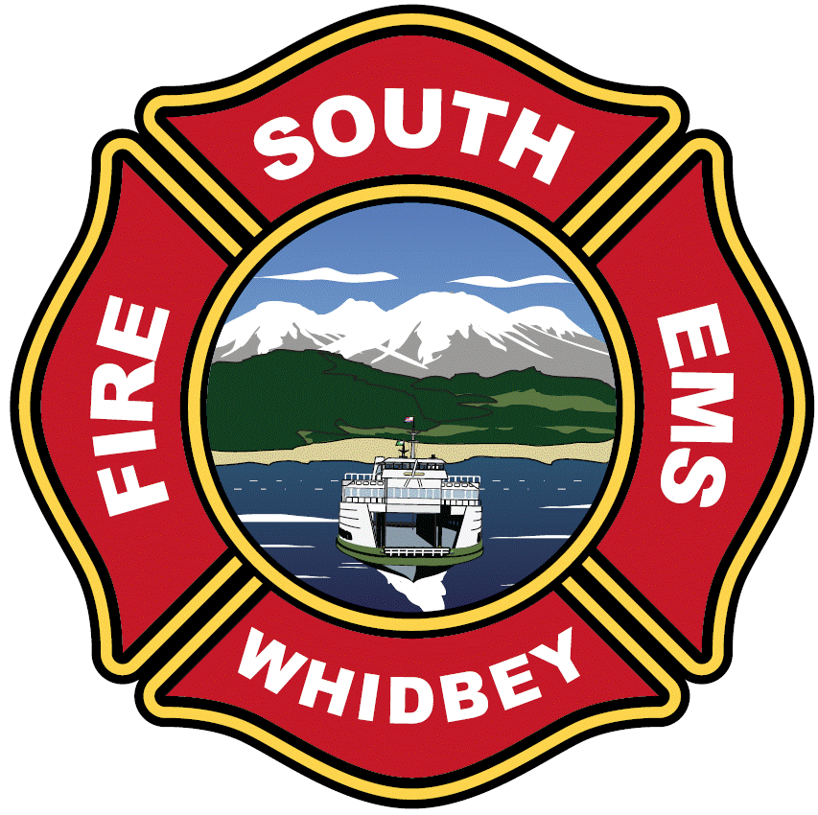

VALUES

The South Whidbey Fire/EMS’ values are INTEGRITY, SERVICE, TRUST

Updated: 12/16/2024

# INTRODUCTION

The purpose of this document is to outline a comprehensive Annual Training Plan for South Whidbey Fire / EMS which builds upon the momentum and foundation of training previously provided to the organization. The structure and content of this plan has been methodically developed to meet the dynamic needs of the organization and its personnel, while simultaneously improving time management and

coordination efforts. While every effort will be made to adhere to the program provided in the following pages, it should be noted that a reasonable amount of flexibility and subsequent revision should be anticipated as additional events and training opportunities develop throughout the course of the year.

The overall goal of this plan and its associated efforts is to provide personnel with the best possible preparatory knowledge, skills, and abilities while subsequently establishing South Whidbey Fire / EMS as a recognized department of safe, efficient, and effective delivery of all-hazards emergency response training. Doing so will ensure fulfillment of our organizational values as we strive *for integrity, service and trust for our community,* through the provision of excellent risk reduction and response services. Furthermore, the safety and effectiveness of our personnel and emergency scene operations will be enhanced through the commitment of these diverse training opportunities.

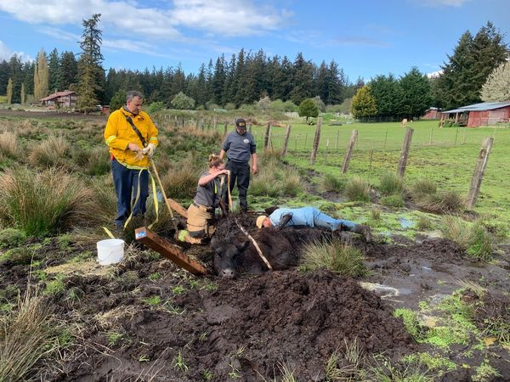

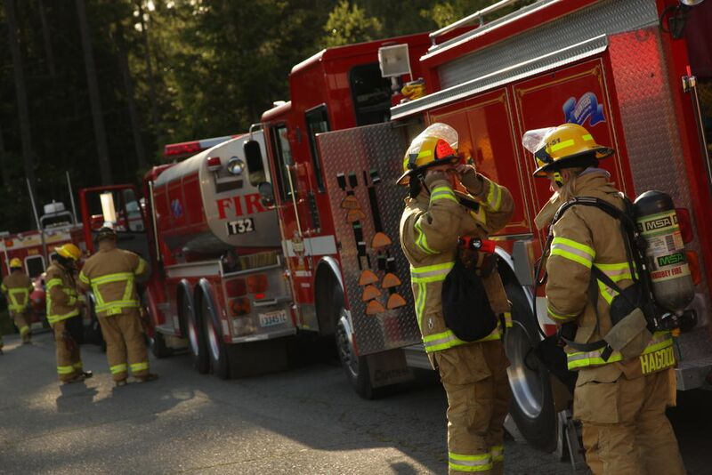

# Training Framework

## Structural Firefighting

***Initial Training and Certification:*** South Whidbey Fire / EMS (SWFE) requires all structural firefighters to be trained and certified as an International Fire Service Accreditation Congress (IFSAC) firefighter 1 or training deemed to be equivalent by the Fire Chief. If an applicant enters the organization with no prior training, SWFE utilize the Island County Fire Academy as a volunteer firefighter and the State Fire Academy for Career Staff to provide training to acquire necessary certifications. SWFE also adds on IFSAC firefighter 2 training and certification to the fire academy. This added training that includes initial command skills, rescue skills, suppression systems, and foam, better prepares or members for what they will face right out of the academy.

***Ongoing Training***: Once Firefighter candidates have completed the recruit academy, or we have a new member with prior firefighter experience and certification, ongoing and skill maintenance training keeps our members at an acceptable level of performance. To accomplish this, SWFE has developed a multi-platform delivery system that includes external training, in-service training, in-station training, and online training. This allow SWFE to maximize hands on training time and multiple varying member availability times in order to ensure our members not only know and retain the skills they have learned, but improve them.

Structural firefighting standard tactical operations including water supply, fire control, search and rescue, ventilation, and on-deck/rapid intervention functions provide a considerable array of critical skills. One way of ensuring that firefighters and officers maintain these skills while understanding the larger picture of tactical operations is to integrate the skills in context.

To provide a framework for training within each of the themes, structural firefighting standard tactics have been integrated within the context evolutions that progress from arrival to accomplishment of the assignment and recycling. Each evolution is terminated with reinforcement of post-fire, on-scene decontamination.

***Important!*** These evolutions are not the only way that tactics and critical skills may be integrated on the fire ground. Each evolution has options that may be used to build tactical flexibility if the participants have mastered the basic skills included in the evolution.

## Standard Tactics

Tactical operations for engine companies and water tenders generally involve a water supply component as an element of task, location, and objective. Standard water supply tactics can be combined with any other tactical option as illustrated in Tables 1 and 2.

### Basic Offensive Tactics

Offensive operations are conducted inside a hazard zone (inside the collapse zone or inside the building). Offensive tactics include (but are not necessarily limited to) the following:

The basic elements of an IAP in the offensive strategy include:

* Quick water for fire control
* Search the involved occupancy
* Tactically ventilate the involved occupancy
* Initiate loss control actions in the involved occupancy

These tactics also require establishment of an adequate water supply to support fire ground operations. As such, Engine Company tactics may be broken down into a water supply component along with basic functional tasks and objectives as illustrated in Table 2.

Table 2. Offensive Tactics

|  |  |
| --- | --- |
| **Water Supply Component** | **Basic Task & Objective** |
| Forward Lay  Dry Forward Lay  Set Up for Tender Shuttle  On a Hydrant  Reverse Lay  None-Park Out of the Way | Stretch an Attack Line, Fire Control (Exterior)  Stretch an Attack Line, Fire Control & Primary Search  Stretch an Attack Line, Primary Search & Check for Extension  Stretch an Attack Line, Go On Deck  Horizontal Ventilation (Post Fire Control)  Positive Pressure Ventilation (Post Fire Control)  Deploy a Ladder & Perform a Physical Rescue  Horizontal Standpipe and Extend an Attack Line (fill in the blank, FC/PS, PS/CE, OD)  Extend an Attack Line off a Horizontal Standpipe (fill in the blank, FC/PS, PS/CE, OD)  Fog Nail, Fire Control  Fog Nail off a Small Horizontal Standpipe, Fire Control  Supply Standpipe & Extend an Attack Line off a Standpipe  Supply Automatic Sprinkler System |

### Basic Defensive Tactics

Defensive operations are conducted outside of the hazard zone, in safe locations. Defensive tactics include (but are not necessarily limited to) the following:

* Quick water for exposure protection and fire control
* Search exposures and check for extension
* Evacuate potentially threatened exposures

These tactics also require establishment of an adequate water supply to support fire ground operations. As such, Engine Company tactics may be broken down into a water supply component along with basic functional tasks and objectives as illustrated in Table 1.

Table 4. Defensive Tactics

|  |  |
| --- | --- |
| **Water Supply Component** | **Basic Task & Objective** |
| Forward Lay  Dry Forward Lay  Set Up for Tender Shuttle  On a Hydrant  Reverse Lay  None-Park Out of the Way | Stretch an Attack Line, Fire Control (Exterior) or Exposure Protection  Deploy Blitzfire, Fire Control or Exposure Protection  Operate Master Stream, Fire Control or Exposure Protection  Supply Elevated Master Stream, fire Control or Exposure Protection  Evacuate Exposures |

## 

## Survival & RIC Skills

Survival and RIC Skills are intended to either be a stand-alone training topic or added to any number of drills that include firefighters operating in a simulated hazard zone.

Table 3. Survival & RIC Skills

|  |
| --- |
| **Basic RIC Skills** |
| Access the patient and size up the situation  Provide Support with Rescue Air Supply in the event of SCBA or mask failure  Evaluate the situation and make a plan for extrication  Communicate your CAN report to the IC stating your plan and needs  Execute your plan |
| **Basic Survival Skills** |
| Situational awareness recognition  Modern fire behavior  SCBA emergency procedures  tool familiarity and use  body mechanics  self-extrication methods |

### Quick Water Offense

An offensive strategy requires rapid and effective application of water on the fire to establish fire control and allow primary search. This theme focuses on quick water application from the exterior and/or interior to address the fire control priority.

***Forward Lay, Fire Control & Primary Search:*** This is a basic evolution for the first arriving engine company at a structure fire occurring in a hydranted area. Tasks include performing a forward lay, stretching an attack line conventional forcible entry (irons), quick hit from the exterior, and performing fire control and primary search. Door control is provided manually by the On-Deck Company (or Apparatus Operator) or a door curtain is placed to provide anti-ventilation until fire control has been achieved.

***Dry Forward Lay, Fire Control & Primary Search:*** This is a basic evolution for the first arriving engine company at a structure fire when the incident location has limited access (e.g., long driveway). Tasks include performing a dry forward lay (from the street), stretching an attack line over a ladder & through a window, and performing fire control and primary search. The first arriving water tender will pump the supply line, establishing a relay until an additional engine arrives and a tender shuttle is initiated. Note: A dry forward lay can also be performed from a hydrant (which essentially involves the same skills as a forward lay, but a member of the attack engine crew does not make the hydrant and supply water to the attack engine).

***On a Hydrant, Fire Control & Primary Search:*** This is a basic evolution when the first arriving engine company at a structure fire when a hydrant is close enough for the Apparatus Operator to stretch the supply line and make hydrant connections. Tasks include stretching a horizontal standpipe and using a hose bundle to extend an attack line through an unlocked door for fire control and primary search. Door control is provided manually by the On-Deck Company (or Apparatus Operator) or a door curtain is placed to provide anti-ventilation until fire control has been achieved.

***Fire Control & Primary Search, Setting Up for Tender Shuttle:*** This is a basic evolution for the first arriving engine company at a structure fire occurring in an unhydranted area when access permits placement of a portable tank adjacent to the attack engine. Tasks include stretching an attack line, conventional forcible entry (irons), and performing fire control and primary search and setting up for a tender shuttle (nurse tender supply while deploying the portable tank). Door control is provided manually by the On-Deck Company (or Apparatus Operator) or a door curtain is placed to provide anti-ventilation until fire control has been achieved.

### On-Deck & Fire ground Support Theme

There are multiple functions necessary to support fire control and primary search in initial fireground operations. These include, positioning of on-deck companies who address the need for two-out and provide readily available tactical reserve, tactical anti-ventilation prior to effective water application, and tactical ventilation once effective water is on the fire. This theme also includes actions required if an individual or crew cannot safely exit the hazard zone. These include, individual and company survival skills and response of on-deck companies as a rapid intervention crew (RIC).

***Survival Skills:*** These skills include dealing with emergencies occurring inside the hazard zone that impact on operating crews. The default options for this evolution include parking out of the way, stretching an attack line off an operating engine (that has a water supply), primary search and check for extension, and a subsequent Mayday event that may include, low air emergency, SCBA malfunction, separation from a hose line, or entanglement. Tasks include Mayday communications, PASS activation, SCBA emergency procedures, re-orientation, disentanglement, and emergency breathing support system (EBSS) operation. These skills are included in this theme to make a connection to the function of on-deck companies as a rapid intervention crew (RIC). Note: In addition to the specific scenario-based evolution, members must demonstrate proficiency in each of the survival skill tasks.

***Rapid Intervention:*** The primary function of and On-Deck company is to serve as a RIC in the event of a Mayday. The default options for this evolution are to park out of the way, stretch an attack line of an operating engine (that has a water supply), go on-deck at the point of entry (inclusive of positioning the rescue air supply), and when tasked, locating a downed firefighter and providing air supply support prior to and during egress, and assisting from extraction of the downed firefighter from the hazard zone.

***Roof Report & Horizontal Ventilation:*** This tactic involves assignment to access the roof and provide a roof report and subsequent reassignment to perform horizontal ventilation from the exterior. The default options for this tactic are to park out of the way, stretch an attack line of an operating engine (that has a water supply), go on-deck at the point of entry (inclusive of positioning the rescue air supply), and when tasked, deployment of a portable ladder and creation of horizontal exhaust openings at the second-floor level and inlet openings at the first-floor level.

***Horizontal Positive Pressure Ventilation:*** This tactic involves assignment to supply an automatic sprinkler system, and subsequently re-tasking to perform horizontal positive pressure ventilation from the exterior. The default options for this tactic are to position on a hydrant, supply an automatic sprinkler system, and when tasked, establish positive pressure ventilation including verification of exhaust openings, deployment of a positive pressure fan and monitoring positive pressure ventilation at the inlet and outlet.

### Quick Water Defense

As with an offensive strategy quick and effective application of water is essential in a defensive strategy. However, in this case, flow rates may be higher, necessitating different water supply tactics.

***Forward Lay, Fire Control:*** This is a basic evolution for the first arriving engine company at a structure fire with defensive fire conditions occurring in a hydranted area. Tasks include performing a forward lay and operating the apparatus mounted master stream for fire control or exposure protection and deploying a blitzfire portable monitor fire control or exposure protection from a second attack position. The second arriving engine will take over the hydrant and pump the attack engine’s supply line, establishing a two-engine relay.

***Reverse Lay, Elevated Master Stream for Fire Control:*** This is a basic evolution for supplying an elevated master stream when a hydrant is reasonably close to the aerial ladder. Tasks include performing a reverse lay, establishing dual pumping, and supplying an elevated master stream.

***On a Hydrant, Fire Control:*** This is the basic evolution for the first arriving engine company at a structure fire when a hydrant is close enough for the Apparatus Operator to stretch the supply line and make hydrant connections. Tasks include stretching a horizontal standpipe to supply the Blitzfire portable master stream for fire control or exposure protection.

***Fire Control & Primary Search, Setting Up for Tender Shuttle:*** This is the basic tactic for the first arriving engine company at a structure fire occurring in an un-hydranted area. Tasks include stretching multiple high-flow attack lines for exposure protection and setting up for a tender shuttle (nurse tender supply while deploying the portable tank).

## Search and Rescue

Threatened occupants of the fire occupancy and significantly threatened exposures must be quickly located and removed from harm (or protected in place). This theme focuses on interior search, evacuation of exposures, and physical rescue over ladders.

***Primary Search, Check for Extension:*** This is a basic evolution for conducting an interior search and check for extension. Tasks include to park out of the way, stretch an attack line of an operating engine (that has a water supply), go on-deck at the point of entry (inclusive of positioning the rescue air supply), and perform an oriented search and then check for extension when tasked.

***Evacuation:*** This evolution involves assisting multiple occupants with limited mobility in egress from uninvolved areas or exposed occupancies. Tasks include, taking over the hydrant and pumping the attack engine’s supply line, and evacuating a specified (attached) exposure and checking for extension. At least one of the occupancies being evacuated will require forcible entry through a door.

***Physical Rescue Over Ladder-Conscious:*** This evolution involves performing a physical rescue of a visible victim at an upper story window when the victim can exit the window onto the ladder. Tasks include being tasked from Level 1 staging for a physical rescue at a specified location, deployment of a portable ladder, and assisting an occupant out from a window and down the ladder.

***Physical Rescue Over Ladder-Unconscious:*** This evolution involves performing a physical rescue of a victim from an upper story window when the victim is unconscious and unable to exit the window unaided. Tasks include being tasked from Level 1 staging for a physical rescue from a specified location, ventilating the window, making entry, establishing door control, removing the victim via the window and down the ladder.

## Emergency Medical Services (EMS) Skills

***Initial Certification:*** Washington State utilizes the National Registry of EMT’s to provide the written examination for all EMT’s. Once the student has completed an approved EMT course, passed the National Registry written exam, proof of completion must be attached to the initial hand-written application and submitted to the Training Officer. After a full review of the application and supporting documents, the Training Officer will then sign the hard copies and forward a copy to the Island County Medical Program Director for approval.

***Recertification***: South Whidbey Fire/EMS uses the Washington State OTEP recertification training process for EMT certification. These topics are split into three separate categories (annual, cycle, and additional) that when completed, allow for submission for approval for recertification.

Once the required classes are completed, the EMS Tracking Sheet (see table 4) is filled out with the supporting documents attached to it and submitted to the Training Captain for review and validation. Simultaneously to the Training Chief reviewing the submitted documents, the individual seeking re-certification needs to complete and submit their individual Washington State Department of Health Online re-certification application.

Once the Training Captain has reviewed the hard copies of the EMT Tacking Sheet and supporting proof of completion, the online application is then reviewed. Once approved online by the Training Chief, the online application then is forwarded to the Island County Medical Program Director for approval. To avoid any laps of certification, this needs to be completed with a minimum of 30 days left before expiration.

***Ongoing Training***: Table 5, lists the topics that are required to be completed for Washington State EMT re-certification. There are four annual topics that needed to be completed once a year and four topics that will be completed once every 3 years.

There is also 30 additional hours of EMS training required to be completed and documented during the three-year certification. The topic for these 30 hours is the choice of the EMT, or can be used as an overflow if an EMT has more hours needed in any one specific topic.

SWFE has also identified specific EMS skills and topics that we have identified to be high frequency for our community. These Topics include quarterly cardiac arrest training and geriatric patient considerations.

Table 5. EMS Recertification

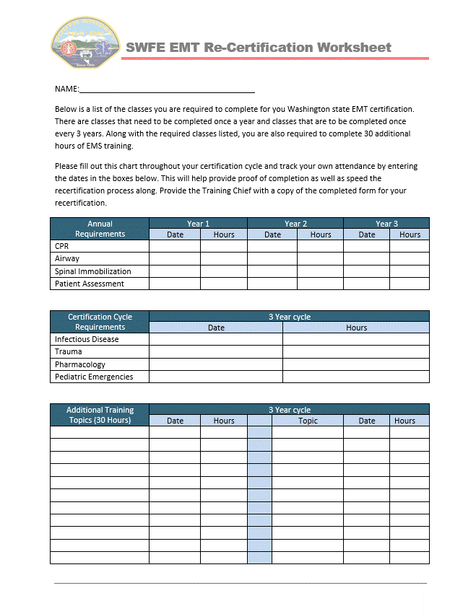

## Technical Rescue Operations

South Whidbey Fire/EMS trains and operates at either an operations level or an awareness level in many technical rescue disciplines. These disciplines include operations level surface water rescue, operations level low angle rope rescue, operations level stabilization and collapse rescue, operations level vehicle and machinery rescue, and currently awareness level trench rescue.

### Marine Rescue

***Initial Certification:*** Becoming a certified member of the Marine Rescue crew starts with a basic knowledge and overview of the vessel and operations. Qualification to the crew begins at the “deckhand” level with the successful completion of the Washington State Online Boater Education course and departmental orientation of the vessel. Although emergency responders are exempt from Washington States’ requirement that all operators poses this certification card, SWFE feels that the information included in this course cuts down on the classroom time for “rules of the water” and basic awareness level information. This 10-dollar online course is a prerequisite for attending the annual Island County multi-agency sponsored Marine Rescue Academy. This 48-hour course was developed to meet the requirement of NFPA 1952 standard for surface water rescue, protective clothing and equipment. This course is a combination of classroom sessions and hands on training focusing on navigation, mapping, boat handling, towing, victim recovery, and tactical maneuvers. Once a member has successfully completed this course, they are now qualified to begin “Coxswain” training. Coxswain training consisted of company officer and peer level in station training that follows the Marine Rescue Vessel section of the SWFE apparatus operator task book (under development).

***Continuing Education:*** In order to maintain proficiency in Marine Rescue Operations, marine rescue operations are scheduled on a rotating quarterly basis to ensure all members are given the opportunity to attend. See training rotation block schedule below.

### Low Angle Rope Rescue

***Initial Certification:*** SWFE operates in a partnership with Central Whidbey Island Fire Rescue for jointly staffing Low angle rope rescue events. Both agencies share instructors and train to the low angle operations level of NFPA 1670 Technical Rope Rescue. Initial training consists of classroom sessions and hands-on field exercises.

***Continuing Education:*** In order to maintain proficiency, low angle rope rescue operations are scheduled on a rotating quarterly basis to ensure all members are given the opportunity to attend. See training rotation block schedule below.

### Stabilization and Collapse Rescue

***Initial Certification:*** Due to the number of occurrences of vehicles into buildings, SWFE operates at a very basic level of collapse rescue and structural stabilization. Members train on basic levels stabilization and carry a very limited amount of materials and tools. As a result, SWFE is partnering with CWIFR who provides ongoing in-service training to provide members with basic construction and tool use knowledge. All training provided is NFPA 1006 compliant.

***Continuing Education:*** In order to maintain proficiency, Structural collapse rescue and stabilization operation training is scheduled on a rotating quarterly basis to ensure all members are given the opportunity to attend. See training rotation block schedule below.

## Apparatus Operator Training

***Initial Certification:*** Before any apparatus specific training is initiated, all members are required to attend and complete a Washington State approved Emergency Vehicle Incident Prevention (EVIP) course. The course SWFE uses, is EVIP

was developed and put together by the Volunteer Fireman Insurance Service (VFIS) and is one of two state approved curriculums for fire agencies to use in the state of Washington. Once the classroom portion and hands on driving rodeo is complete, initial apparatus operator training is delivered through In-Station training based upon the members’ current level of certification and any prior Commercial Driver’s License (CDL) certification experience. Apparatus operators with prior CDL certification or experience can begin training on heavy and pumping apparatus while members with no commercial driving experience are required to begin on light apparatus. SWFE uses the SWFE Apparatus Operator Task Book and the SWFE Hydraulics Manual guides to getting member certified on a specific piece of apparatus.

***Continuing Education:*** While the tasks books and manuals used for initial certification are a good tool to use in the beginning, apparatus operator continuing education requires a minimum of 4 Hours of classroom time and an over the road evaluation of driving annually. SWFE has also identified other skills and training topics that are included annually for continuing certification to include in Table 6 below.

Table 6. Apparatus Operator Ongoing Training

|  |
| --- |
| **Additional A/O ongoing training topics** |
| Hydrant Operations and Tank to Hydrant Change-Over  Horizontal Standpipes & Wyed Lines  Streets & Addressing  Trailering Operations  Supplying Fire Protection Systems (Sprinklers & Standpipes)  Water Supply Troubleshooting  Remote Operated Master Streams  Reverse Lay, Supply Aerial Master Stream (simulated)  Setting Up for Tender Shuttle  Taking Over a Hydrant & Relay Operations  On a Hydrant (varied distances)  Portable Tank Deployment & Drafting  Class B Foam Operations  Water Supply Group Supervisor Training  Relay Hydraulics |

# Training Distribution and Rotation

The South Whidbey Fire/EMS Training Division designs, manages, and evaluates professional development programs which enhance life safety for our firefighters and community. The Training Division is responsible for the initial training of new trainees, providing on-going professional evaluation and development for our members, and provides a clear path for current member who wish to promote to a higher level or expand their own operational capability. We develop, deliver, and evaluate training programs to ensure that all individuals within the District are able to perform their duties safely, effectively, and efficiently.

SWFE faces many of the same challenges that other combination departments across the county face. These challenges include offering not only the right topics and opportunities, but being able to evenly and effectively distribute them to members who are on a variety of differing schedules or have varying levels of training availability. Being able to distribute the training evenly to all member of the District and on a rotating basis that allows for this can be a challenging task.

South Whidbey Fire/EMS has full-Time employees, and volunteers who serves on vastly different schedules. Some live within the district, and some live outside the district. This presents us with significant challenges with distribution and efficiency. In designing the South Whidbey annual training plan, we looked at all the essential job functions and training requirements, as well as the rotation and availability of our members. Within this plan, these disciplines and topics are distributed throughout this one-year cycle and are on a re-occurring basis so that by the end of the year cycle, everyone should have been offered the same opportunities and training courses.

Another challenge SWFE faces from time to time are opportunities arise for training outside the specifically identified topics. By breaking down the years into Terms, (quarterly blocks) we have been able to retain the vehicle inspection and readiness nights as well as build an open week into the end of every term that allows some flexibility for opportunities that arise or for the individuals or individual crews to custom tailor topics that may have been missed or needed to be rescheduled.

***In-Service Training:*** Highlighted in red in the table below is what SWFE classify as In-Service Training. This training is delivered by Administration staff, the Training Division staff or their designee.

***In-Station Training:*** Highlighted in green below,this training is designed to allow the company level officers and leaders the opportunity to tailor and customize the given topics around their individual company needs. The training topic is then delivered to the companies by the company officer.

***Online Training:*** SWFE utilizes the online training provider Target Solutions to deliver many mandated and regulatory trainings along with many EMS based classes. Listed in Blue below, this allows for members to complete many classes online while maximizing face to face instructor time. Some training like the Blue Card Incident Command Course incorporates required online CE courses that pair with In-Service training delivered by Blue card certified instructors.

***External Training:*** Outside training courses are available to members on an ongoing basis as they become available or the need is identified.

***Rotation:*** The year is split up into four, three-month quarters and each quarter is divided into three- month long blocks. This allows SWFE to evenly distribute the topics over the year to ensure all members of the District.

***Scheduling***: On a basic level, the scheduling and rotation are broken down like this;

1. Sunday
   1. Online Training Is released at the beginning of the month
   2. In-Station training delivered by company officer on a specified topic designated by the company officers
   3. In-service training on A/O skills inclusive of Apparatus Operator Task book sign offs.
2. Monday –Thursday
   1. Weekly Fire/EMS in-service trainings topics that happen on Monday, Tuesday, Wednesday and Thursday are identical to ensure every shift receives the same training. Monday and Wednesday training is trained by the duty Lieutenant and Tuesday trainings are conducted by Career, Volunteer Officers and Subject Matter Experts at 7pm to allow volunteer member to receive the same training.
3. Thursday
   1. Special operations training if needed
4. Friday
   1. In-Station training delivered by company officer on a specified topic by the company officer
5. Saturday
   1. In-Station training delivered by company officer on a specified topic
   2. In-service training on A/O skills inclusive of Apparatus Operator Task book sign offs.

|  |  |  |  |  |  |  |
| --- | --- | --- | --- | --- | --- | --- |
| **Sunday** | **Monday** | **Tuesday** | **Wednesday** | **Thursday** | **Friday** | **Saturday** |
| **On-Line Training**  **In-station Training** 1 Hour | **In-Service Training** Fire/EMS 2 Hours | **In-Service Training** Fire/EMS 2 Hours (Evening) | **In-Service Training** Fire/EMS 2 Hours | **In-Service Training** Special Operations 2 Hours | **In-Station Training** 2 Hours | **In-Station Training** Apparatus Operator 2 Hours |

# TRAINING TYPES

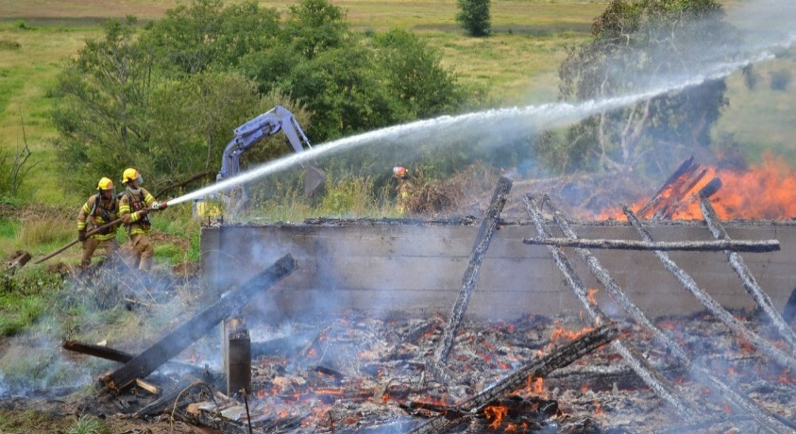There are different types of training. These shall be known as delivery modalities. Training delivery modalities include Regulated, Required, Mandated, and Voluntary. Each modality has independent requirements and procedures, which are outlined below.

## REGULATED

There are several components with the Washington Administrative Code (WAC) related to fire service training. There will be strict compliance of WAC regulated training to ensure the safety of our personnel. All WAC regulated training will be managed using Target Solutions with regular record audits to ensure we are in full compliance. The Division Chief of Training Division ensure personnel on the different shifts and stations through the Shift Lieutenants and Volunteer Captains have the opportunity to attend physical training and attendance is scheduled appropriately.

Multi-Company (MCO) drills are regulated quarterly. MCO’s for SWFE purposes can include two or more units conducting HOT in full personal protective equipment (PPE). Special Operations team training will not replace quarterly required MCO training.

WAC regulated training delivery platforms will include hands-on training (HOT), Target Solutions (TS) individual and company level, and lectures. (See Table 1)

## REQUIRED

Required training is generally associated with advanced certifications or specialty training. Required training examples include Hazardous Material (HM) team training, Technical Rescue (TR), EMT, Rope Rescue, Marine, Wildland (WL), CPR, and others. Required training will be offered on-duty in the form of weekly, quarterly, and/or yearly training as required, and Target Solutions.

## MANDATED

Mandated training is training required by the Department. Department mandated training for approved certifications or for promotional requirements will be compensated at the employee’s regular hourly rate and/or overtime, if applicable.

## VOLUNTARY

Upon request by the employee, the Department may approve additional voluntary training time that is above and beyond what is mandated by the Department. The Department will only consider additional voluntary training requests from employees who have graduated the Academy. Voluntary Training must be pre-approved by the Training Division.

Table 1

|  |  |  |  |  |
| --- | --- | --- | --- | --- |
| **Annual Mandatory Training (per WAC)** | | | |  |
| Training | WAC | Responsibility | Platform | Target Month |
| Asbestos | 296-62-07722 | Training Division | TS |  |
| Chemical Hazard Communication | 296-800-170 | Training Division | TS |  |
| Hearing Protection | 296-305-02004 | Training Division | TS (EMS Course) |  |
| Haz-Mat Awareness MOD2 | 296-824 | Training Division | TS |  |
| Heat Awareness | 296-305-05004 | Training Division | TS |  |
| ARFF Awareness | 296-305-05013 | Training Division | TS |  |
| Portable Fire Extinguishers | 296-800-30025 | Training Division | TS |  |
| Haz-Mat Awareness MOD3 | 296-824 | Training Division | TS |  |
| Overhaul Procedures | 296-305-05000 | Training Division | TS |  |
| Respiratory Protection | 296-842-16005(2)  296-305-04001(17) | Training Division | TS |  |
| EVIP | 296-305-04505 | Training Division | TS |  |
| Spec Ops Awareness Lockout/Tagout | 296-305-05113  296-45-065 | Training Division | TS |  |
| Haz-Mat Awareness MOD4 | 296-824 | Training Division | TS |  |
| Cold Weather | 296-305-05004 | Training Division | TS (EMS Course) |  |
| Active Shooter |  | Training | TS |  |
| Ice Rescue |  | Training | TS (EMS Course) |  |
| First Aid Training & Certification | 296-305-01515(1) | Training Division | TS (OTEP) |  |
| Infectious Disease Awareness | 296-305-02501 | Training Division | TS (EMS Course) |  |
| Haz-Mat Awareness MOD1 | 296-824 | Training Division | TS |  |
| SCBA Quarterly Don for Time Q1 | 296-305-04001 | Company Officer | HOT |  |
| Ground Ladders | 296-305-06006 | Company Officer | HOT |  |
| Wildland Red Card Refresher | 296-305-07010 - 19 | Training Division | HOT & TS |  |
| MCO | 296-305-05502 | Company Officer/ Training Division | HOT |  |
| SCBA Quarterly Don for Time Q2 | 296-305-04001 | Company Officer | HOT |  |
| Hose, Appliances, Hose Loads |  | Company Officer | HOT |  |
| Live Fire Training  Command, Tactical Communications  Attack & Supply, Ladder Ops,  Ventilation | 296-305-05502 | Training Division | HOT |  |
| MCO |  | Company Officer/ Training Division | HOT |  |
| SCBA Quarterly Don for Time Q3 | 296-305-04001 | Company Officer | HOT |  |
| EVIP/EVDT | 296-305-04505 | Training Division |  |  |
| Ventilation | 296-305-05502 | Company Officer | HOT |  |
| Live Fire Training  Command, Tactical Communications  Attack & Supply, Ladder Ops,  Ventilation | 296-305-05502 | Training Division | HOT |  |
| SCBA Quarterly Don for Time Q4 | 296-305-04001 | Company Officer | HOT |  |
| Fireground Search |  | Company Officer | HOT |  |
|  |  |  |  |  |

# HANDS-ON TRAINING

## PRIORITY GROUND LADDERS HOT

90m Sessions 4/Day TBD

## INCIDENT COMMAND (IC) CR & Evolutions

3-Hour Sessions 2/Day TBD

45-Min Classroom, 2 hour 15 min TBD

## WILDLAND REFRESHER

3-Hour Sessions 2/Day April

## MCO

EMS Training Included TBD

## LIVE FIRE TRAINING (LFT) (MCO)

EMS Training Included TBD

## MCO

3-Hour Sessions 2/Day TBD

EMS Training Included TBD

## WOMEN in FIRE CONF HOT

Nozzle Forward, Stress Inoculation, & More TBD

## FIREGROUND SEARCH HOT

90m Sessions 4/Day TBD

2 Mutual Engine and TBD

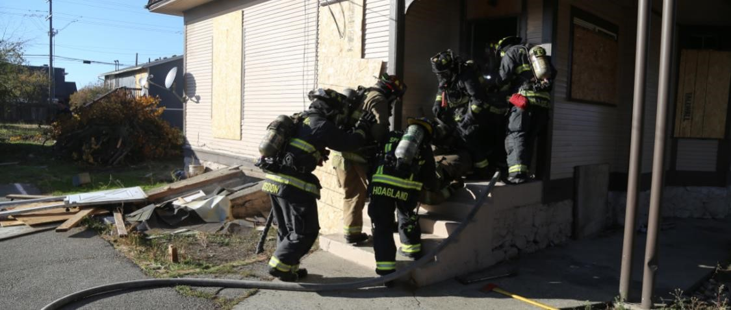

# CLASSROOM & CLINIC TRAINING

|  |  |  |
| --- | --- | --- |
|  |  |  |
| **Classroom (CR) or Clinic (CL) Model**  4- 90/min sessions, 1/Day per Shift  Open to Mutual FD up to occupancy limit  No Fills required TBD    **Topics:**  **Hose, Appliances, Hoseloads CL**  90m Sessions 4/Day (Balanced) TBD |  | **Classroom (CR) or Clinic (CL) Model**  2- 3.5-hour sessions, 2/Days per Shift  Open to Mutual FD up to occupancy limit  No Fills required TBD    **Topics:**  **TBD**  (Balanced)  **TBD (B), (C), (D), (A)** 0900-1230 & 1300-1630  **TBD (B), (C), (D), (A)** 0900-1230 & 1300-1630 |

## EVIP RODEO CL

90m Sessions 4/Day (Balanced) March

## VENTILATION CL

90m Sessions 4/Day (Balanced) TBD

## ACTIVE SHOOTER CL

90m Sessions 4/Day (Balanced) TBD

# SPECIAL OPS & EMS TRAINING

**Hazardous Materials Team:**

Weekly Training. TBD

|  |
| --- |
| Quarterly Training: TBD |
| HM Specialist School: TBD |
| HM Leadership Training: TBD |

**Rope Rescue Team:**

Monthly Training: 3th Thursday of the month

**Marine:**

Weekly Training: 1/19 & 1/23; 2/21 & 2/27; 3/23 & 3/27; 4/24 & 4/25; 5/22 & 5/23; 6/22 & 6/27; 7/24 & 7/25; 8/24 & 8/28; 9/25 & 9/28; 10/23 & 10/26; 11/21 & 11/23; 12/19 & 12/21;

**Rescue Task Force:**

Weekly Training on select Fridays: TBD

|  |  |  |
| --- | --- | --- |
| Quarterly Training: TBD    **Wildland** |  |  |
| Yearly Refresher: April |  |  |
|  |  |  |

**EMS Training:**

Pit Crew: TBD

Infectious Disease/Blood Borne (Also recorded): TBD

EMT Psycho Motor Rodeo: TBD

Report Writing: TBD OSI: TBD

**Logistics:**

Testing, Pump Test**:** TBD

**PPE Advanced Inspection:** TBD

|  |  |
| --- | --- |
| **JANUARY** | |
| FIRE  SUPPRESSION | Workplace Harassment Awareness- Week 1  Safety & Traffic Accidents (Target Solutions) - Week 2  EV training, hands on examination & Fit tests- Week 3  PPE/SCBA Competencies (Quarterlies and Inspections) & Forward Lay Single Company Operations (NFPA 1410) and Fit tests - Week 4 |
| DRIVER/ OPERATOR | Pumper - Apparatus pre-trip & tool inspection Training/Drive Time |
| EMERGENCY  MEDICAL  SERVICES | ACLS |
| OFFICER  DEVELOPMENT | Today’s Fire Officer & Servant Leadership  Sims Sets and Reps |
| HAZARDOUS MATERIALS | Drug lab dangers |
| Ropes Team | Direct construction and operation of MA system |
| Marine Team | Apparatus Checks & rough weather if possible |
| **FEBRUARY** | |
| FIRE  SUPPRESSION | Hydrant & Pump Operations - Week 1  Hearing Conservation & NFPA 1001 FF (Target Solutions) - Week 2  All Officers Meeting – Week 3  Structural Collapse, Self-Rescue, Denver Prop & RIT teams- Week 4 |
| DRIVER/ OPERATOR | Pumper - Pump Calculations  Pumper - Appliance Special Considerations |
| EMERGENCY  MEDICAL  SERVICES | Pediatric Respiratory Emergencies  Drill: Peds mega-code |
| OFFICER  DEVELOPMENT | Administrative Documentation  Sims Sets and Reps |
| HAZARDOUS MATERIALS | Hazardous Materials Containers |
| Ropes Team | Low angle techniques |
| Marine Team | Trailering/Towing/Backing & rough weather if possible |

|  |  |
| --- | --- |
| **MARCH** | |
| FIRE  SUPPRESSION | EVIP & Portable Fire Extinguishers – Week 1  Wildland (Target Solutions) – Week 2  EVIP catch-up, 1st quarter make-ups – Week 3  Forcible entry – Week 4 |
| DRIVER/ OPERATOR | Pumper - Apparatus Familiarization  Pumper - Pump pre-connect from take to 1st, 2nd 3rd floor of structure |
| EMERGENCY  MEDICAL  SERVICES | Pediatric Cardiology and Endocrine Emergencies |
| OFFICER  DEVELOPMENT | ICS for Emergency Incidents  Sims Sets and Reps |
| HAZARDOUS MATERIALS | ID community risk areas (buildings, businesses, etc.) |
| Ropes Team | Direct personnel in the construction and operation of lowering device |
| Marine Team | "Around the horn" Trailering - Launching - Recovery- REPS |
| **APRIL** | |
| FIRE  SUPPRESSION | Ladders & Fall Protection – Classroom Week 1  Water rescue training TBD (Target Solutions) – Week 2  Chain Saws & Pack Tests (for Red Cards)– Week 3  Roof Operations - Hands on – Week 4  PPE/SCBA Competencies (Quarterlies and Inspections) – Week 5 |
| DRIVER/ OPERATOR | Pumper - Supply sprinkler or stand pipe  Pumper - Relay pump from pumper to pumper |
| EMERGENCY  MEDICAL  SERVICES | Chest Trauma |
| OFFICER  DEVELOPMENT | Command of Structure Fires  Sims Sets and Reps |
| HAZARDOUS MATERIALS | In-home materials that react with water & fire |
| Ropes Team | High angle scenario |
| Marine Team | GPS Navigation |

|  |  |
| --- | --- |
| **MAY** | |
| FIRE  SUPPRESSION | Decon/MCI trailers & Rehab, hot zone focus – Week 1  Heat Stress (Target Solutions) – Week 2  Search & Rescue – Week 3  All Officers Meeting – Week 4 |
| DRIVER/ OPERATOR | EVDT Refresher  Pumper - Pump single line master stream with elevation |
| EMERGENCY  MEDICAL  SERVICES | Fall Injuries and Geriatric Trauma  Drill: Spinal injuries |
| OFFICER  DEVELOPMENT | Human Resources at the Officer Level  Sims Sets and Reps |
| HAZARDOUS MATERIALS | HazMat Trailer/Decon |
| Ropes Team | Tie knots, bends, and hitches and/or team lead’s choice |
| Marine Team | NASBLA Boat Crew or BOSAR Class??? |
| **JUNE** | |
| FIRE  SUPPRESSION | ICS/Command/SIMS/Radio procedures – Week 1  Confined Space Awareness (Target Solutions) – Week 2  Relay Pumping – Week 3  Drafting – Week 4 |
| DRIVER/ OPERATOR | Pumper - Pump gated wye, supply 2 lines with fog nozzles |
| EMERGENCY  MEDICAL  SERVICES | Drowning and Environmental Emergencies |
| OFFICER  DEVELOPMENT | Preplanning/Inspections  Sims Sets and Reps |
| HAZARDOUS MATERIALS | Langley Waste Treatment Plant Walk-through (TBD) |
| Ropes Team | Construct both single & multi-point anchor systems and/or team lead’s choice |
| Marine Team | Emergency procedures, Maydays |

|  |  |
| --- | --- |
| **JULY** | |
| FIRE  SUPPRESSION | Map reviews, hydrants, boat launches, etc. – Week 1  GHS Hazcom (Target Solutions) – Week 2  MVC/TIMS review (LE guest speaker) – Week 3  Fair Walk-through – Week 4  PPE/SCBA Competencies (Quarterlies and Inspections), RIT Pack Training – Week 5 |
| DRIVER/ OPERATOR | Pumper - Relay pumping from static source |
| EMERGENCY  MEDICAL  SERVICES | Make-up |
| OFFICER  DEVELOPMENT | Tabletop Exercise [Emergency Management] – Fair Planning  Sims Sets and Reps |
| HAZARDOUS MATERIALS | Dam, Dike, & Divert training |
| Ropes Team | System safety checks and/or team lead’s choice |
| Marine Team | MOB, Rescue Techniques, Patient movement (boat-boat) |
| **AUGUST** | |
| FIRE  SUPPRESSION | Terrorism/Ferry interaction– Week 1  Asbestos – Week 2  Denver Drill (possible saw work)– Week 3  Overhaul/EV/Open for meeting– Week 4 |
| DRIVER/ OPERATOR | Pumper - Apply knowledge & skills to operate apparatus on the scene of a large scale incident |
| EMERGENCY  MEDICAL  SERVICES | Make-up |
| OFFICER  DEVELOPMENT | Mentorship in the Fire Service  Sims Sets and Reps |
| HAZARDOUS MATERIALS | Terrorist activity |
| Ropes Team | Construct and operate belay system to catch a falling load and/or team lead’s choice |
| Marine Team | Swim Qualifications |

|  |  |
| --- | --- |
| **SEPTEMBER** | |
| FIRE  SUPPRESSION | Vehicle Extrication – Week 1  Gases – Week 2  Propane Fire (hands on, possibly at 54)/open for meeting – Week 3  Hazmat drill, hands on – Week 4 |
| DRIVER/ OPERATOR | Pumper - Utilize standpipe operations |
| EMERGENCY  MEDICAL  SERVICES | CAM Course  Drill: Adult mega-code, OD |
| OFFICER  DEVELOPMENT | Calm the Chaos Refresher  Sims Sets and Reps |
| HAZARDOUS MATERIALS | Nicholes Brothers Emergencies |
| Ropes Team | Tie knots, bends, and hitches |
| Marine Team | Firefighting- Boat to boat |
| **OCTOBER** | |
| FIRE  SUPPRESSION | PTSI/Suicide Prevention & Forcible Entry – Week 1  Forcible Entry Tool Safety – Week 2  MCI (tied in with EMS training) – Week 3  PPE/SCBA Competencies (Quarterlies and Inspections) – Week 4 |
| DRIVER/ OPERATOR | Tender/Pumper - Winter driving safety |
| EMERGENCY  MEDICAL  SERVICES | Sepsis |
| OFFICER  DEVELOPMENT | Generational Differences in the Fire Services  Sims Sets and Reps |
| HAZARDOUS MATERIALS | Hazard classes 1-4 review |
| Ropes Team | Construct both single and multi-point anchor systems |
| Marine Team | Firefighting- Boat to shore |

|  |  |
| --- | --- |
| **NOVEMBER** | |
| FIRE  SUPPRESSION | Cold Weather Preparation Drill (Chains) – Week 1  HIPPA (Target Solutions) – Week 2  Trench/Animal Rescue – Week 3  Thanksgiving – No Drill – Week 4 |
| DRIVER/ OPERATOR | Pumper - Proper positioning of apparatus on special hazards  Pumper - Proper positioning of apparatus on target buildings |
| EMERGENCY  MEDICAL  SERVICES | Abdominal pain  Drill: Medical eval, abdominal pain |
| OFFICER  DEVELOPMENT | Individual Employee Training Plans  Sims Sets and Reps |
| HAZARDOUS MATERIALS | ERG Review |
| Ropes Team | System safety checks |
| Marine Team | Paper Charts, Search Theory |
| **DECEMBER** | |
| FIRE  SUPPRESSION | First Aid for First Responders – Week 1  Make-up for Target Solutions Training (Target Solutions) – Week 2  Air monitoring & Officers meeting – Week 3  Christmas Week No Drill – Week 4  New Year’s Eve No Drill - Week 5 |
| DRIVER/ OPERATOR | Target Solutions  End of Year Make Up Trainings |
| EMERGENCY  MEDICAL  SERVICES | Altered Mental Status & Stroke |
| OFFICER  DEVELOPMENT | Individual Assessment and Meeting with Chief Dilley  Sims Sets and Reps |
| HAZARDOUS MATERIALS | Hazard classes 5-9 review |
| Ropes Team | Construct and operate belay system to catch a falling load |
| Marine Team | Boat Handling Skills |