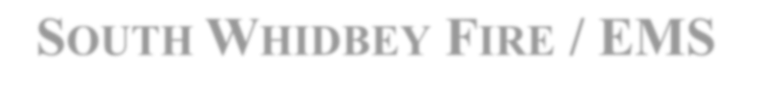

**SOUTH WHIDBEY FIRE / EMS**

**5579 Bayview Road** • **Langley, WA 98260**

**(360)321-1533** • **Fax (360)321-9385** • [**www.swfe.org**](http://www.swfe.org/)

# Expenditure Approval Document Date of Approval: September 10, 2024

Fund: 638

Warrants Approved

September 1, 2024 – September 30, 2024

|  |  |  |  |
| --- | --- | --- | --- |
| Date | Voucher | Description | Amount |
| 9/3/2024 | 240903001-240903009 | Accounts Payable | $8,823.81 |
| 9/05/2024 | EFT | Payroll | $62,787.34 |
| 9/6/2024 | 240906001 | Payroll | $353.71 |
| 9/19/2024 | EFT | Payroll | $63,319.35 |
| 9/20/2024 | 240908001-240908031 | Accounts Payable | $40,782.74 |
| 9/27/2024 | 241001001-241001024 | Accounts Payable | $51,750.78 |
| 9/1-9/30/2024 | EFT | Payroll Liabilities | $107,088.20 |
|  |  | **Total Warrants Approved** | **$334,905.93** |

I, the undersigned, do hereby certify under penalty of perjury that the materials have been furnished, the services rendered, or the labor performed as described herein, that any advance payment is due and payable according to a contract or is available as an option for full or partial fulfillment of a contractual obligation and that the claim is a just, due and unpaid obligation against South Whidbey Fire/EMS, and that I am authorized to authenticate and certify to said claim.

**Finance Officer: Fire Chief: Mary Kaye Johansen Nick Walsh**

**Commissioner: Commissioner:**

**Michael Noblet Savannah Erickson**

**Commissioner:**

**Jim Towers**