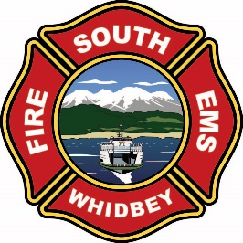
CHIEFS REPORT
NOVEMBER 2025

STAFFING AND VOLUNTEER ENGAGEMENT

STAFFING REPORTS
Fourth seat coverage was at 70% (down from 71%)
Fifth seat coverage was at 29% (down from 36%)
Sixth seat coverage was at 2% (down from 10%)

RECRUITMENT AND RETENTION
New volunteers in process
0- New volunteer members ready for approval
3- Applications in process
- Volunteer resignations

- New career firefighter/EMT conditional job offer sent

TOTAL NUMBER OF VOLUNTEERS

VOLUNTEER PARTICIPATION BY TOTAL HOURS PER QUARTER

RESOURCE
- Apparatus Committee agreed to move on a Pierce Semi-Custom Engine.
- Trenches are dug for Propane and Electric lines for the Training Center. These will be installed in the next few weeks.
- Waiting on parts for a couple of vehicle repairs.
- Damien Clay, the maintenance Technician started on the 10th.
- Fire Alarms are being repaired and switched to a different monitoring company.

OPERATIONS
- Conducted interviews of potential career firefighters, extended one job offer.
- Opened the testing process to hire additional career member for the February academy.
- Continuing to work out the short comings of the BC tones.
- Staffing with a minimum of four firefighters.
- Continuing to work on the transport billing for EMS.

TRAINING DIVISION
Busy month of training!
Outside training: Peer support, fire investigation, officer development, and using ladders.
Department training: Suicide prevention, forcible entry, using building standpipes, and recognizing/treating septic patients.
Registration for the next quarter of National Fire Academy classes is also open for 2 weeks.

RECENT EVENTS
Final All staff meeting for Mission Statement and Values
FF Wrightson graduated state fire academy
Extended employment offer to 1 new career firefighter

UPCOMING EVENTS
Santas Sleigh December 4th, 5th, & 6th
Christmas Party December 13th
Seattle Stair climb March 8th

