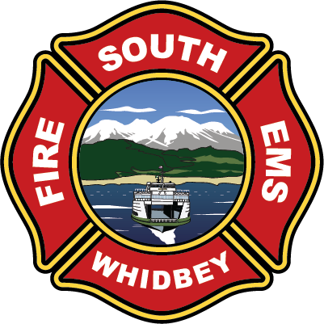
South Whidbey Fire / EMS
5579 Bayview Road Langley, WA 98260
(360) 321-1533 Fax (360) 321-9385 www.swfe.org

Public Meeting
Wednesday, October 29, 2025 at 5:30pm
Agenda
Join Zoom Meeting
https://us06web.zoom.us/j/2208026387?pwd=WWNSR3JscUhZK3ZHU3JOV05ZOHF1UT09&omn=87987710600
Meeting ID: 220 802 6387
Passcode: 926342
One tap mobile
+12532158782,,2208026387#,,,,*926342# US (Tacoma)
+12532050468,,2208026387#,,,,*926342# US

- Call to Order
- Approval of Agenda
- Presentation of Strategic Plan
- Open Session with Public
- Resume Board Panel
- Chair Closing Remarks
- Adjourn

