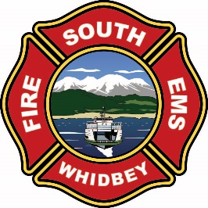
CHIEFS REPORT
July 2026
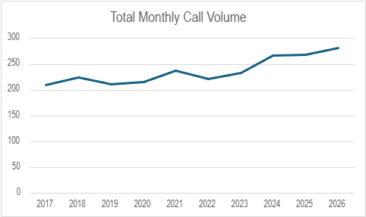

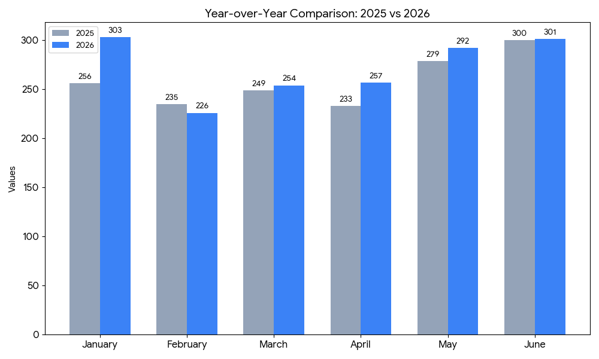
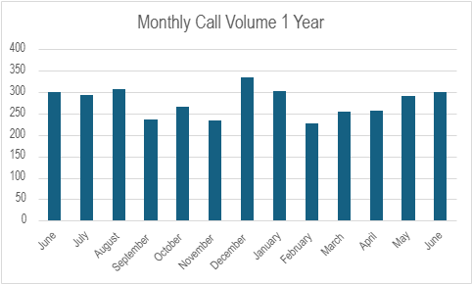

STAFFING AND VOLUNTEER ENGAGEMENT
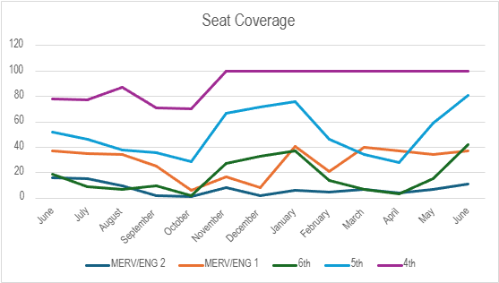

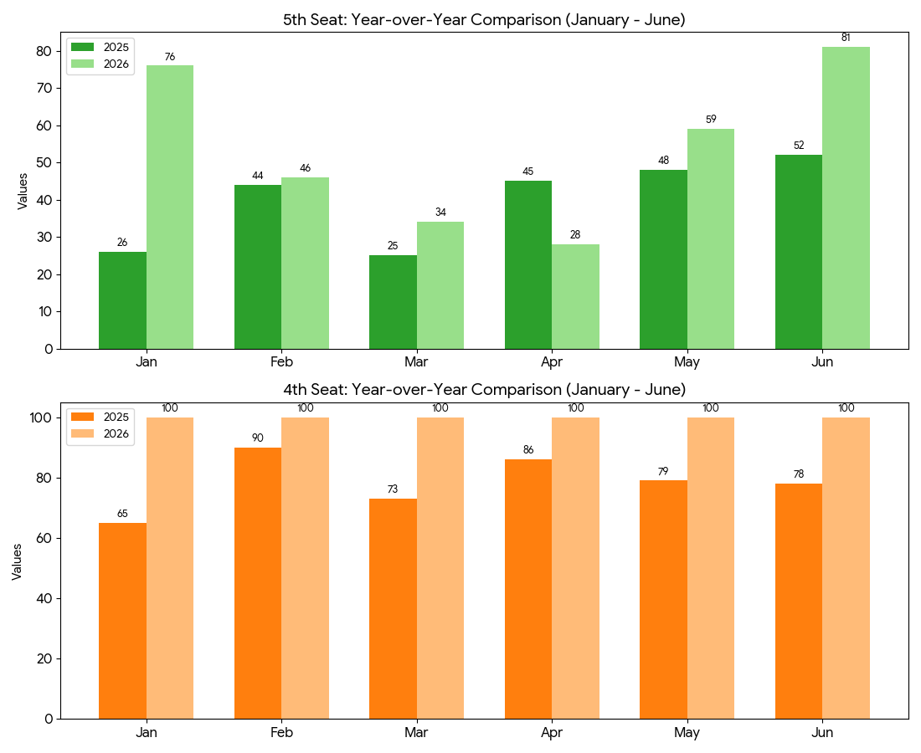

STAFFING REPORTS
Fourth seat coverage was at 100%
Fifth seat coverage was at 81% (up from 59%) +22%
Sixth seat coverage was at 42% (up from 15%) +27%
We still have two on parental leave. However with the newest recruits not yet cleared for full duty, our 5th and 6th seat coverage remain high. The down side of this high coverage has been increased overtime. Merv coverage continues to improve over the summer.

RECRUITMENT AND RETENTION
New volunteers in process
0- New volunteer members ready for approval
4- Applications in process
1- Volunteer resignations

TOTAL NUMBER OF VOLUNTEERS

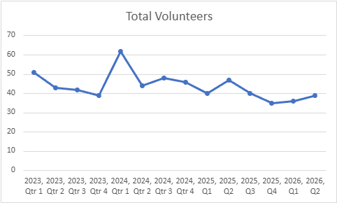
39 up from 36

VOLUNTEER PARTICIPATION BY TOTAL HOURS PER QUARTER
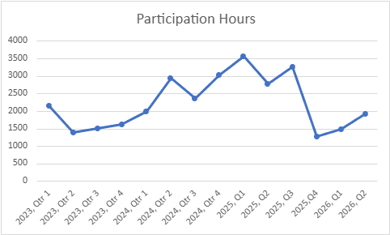

Operations-
• SWFE responded to multiple brush/structural fires in the last few weeks. We had two firefighters injured with a close call when the house exploded. Both are doing well.
• SWFE continues to work on an agreement with the City of Langley for fire inspections.
• The Volunteer Academy is underway with six South Whidbey Fire/EMS volunteers participating. Lt. Wilkie is serving as the Company Officer for the Academy.
• We have had one Wildland deployment so far. Deployments are on hold for a few weeks due to training.
• There is a pump academy happening now for the probationary firefighters to get them to the operator level.
Resource-
• Ian was able to get two Engines back in service.
• Construction of the new Pierce Saber engine is underway.
• The new SAFE boat is currently under construction.
• Parking lot lines have been painted at 36, and 31.
• Maintenance personnel continue to prepare maintenance facility for surplus
• Command 303 will be heading up to Frontier Ford to be assessed and repaired after the close call explosion at the house fire.
• SWFE is still waiting to receive bigger purchases, SCBA extractor (Washing Machine) and Gear Dryer.
TRAINING DIVISION
- Decon training
- Spinal injuries
- PSE, electrical familiarization
- ICS & Command scenarios
- The volunteer academy:
- Took their FF 1 written test
- Live fire practice
- Finished week 8 of 14

UPCOMING EVENTS
Island County Fair TTX, July 15
Island County Fair, July 23rd- 26
National Night Out, August 4
SWFE annual picnic and pinning ceremony, August 22

