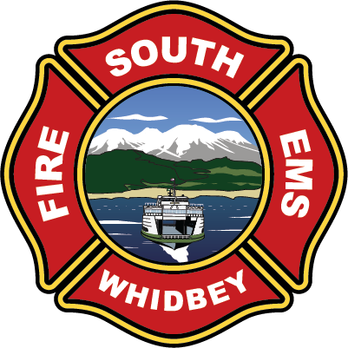

**South Whidbey Fire / EMS**

**5579 Bayview Road • Langley, WA 98260**

**(360) 321-1533 • Fax (360) 321-9385 • www.swfe.org**

***Special Meeting of the Board of Commissioners***

***Friday, September 26, 2025 at 1:00pm***

**Agenda**

Join Zoom Meeting

<https://us06web.zoom.us/j/2208026387?pwd=WWNSR3JscUhZK3ZHU3JOV05ZOHF1UT09&omn=83922484826>

Meeting ID: 220 802 6387

Passcode: 926342

One tap mobile

+12532158782,,2208026387#,,,,*926342# US (Tacoma)

+12532050468,,2208026387#,,,,*926342# US

1. **Call to Order**
2. **Approval of Agenda**
3. **Strategic Planning**

1. **Conclude**