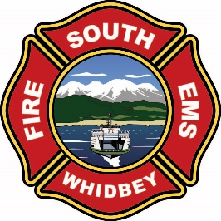
CHIEFS REPORT
May 2026

STAFFING AND VOLUNTEER ENGAGEMENT

STAFFING REPORTS
Fourth seat coverage was at 100%
Fifth seat coverage was at 28% (down from 34%) -6%
Sixth seat coverage was at 3% (down from 7%) -4%
The low 5th/6th seat coverage was secondary to 4 staff being assigned to fire academy, one on LWOP, one on light duty (maternity). On a positive note, much of the MERV time represents 2 members on a MERV.

RECRUITMENT AND RETENTION
New volunteers in process
4- New volunteer members ready for approval
2- Applications in process
1- Volunteer resignations

TOTAL NUMBER OF VOLUNTEERS
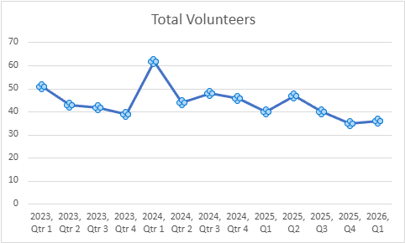

VOLUNTEER PARTICIPATION BY TOTAL HOURS PER QUARTER
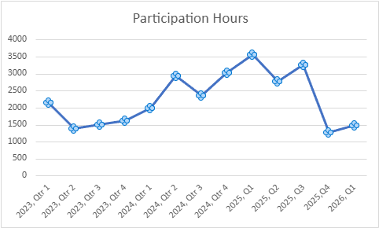

Operations-
- Academy Graduation is May 18th. Firefighters go to shift starting May 18th. This will give us at least six assigned to each shift.
- The flatbed is ready for wildland fires and has the Skid unit on it.
- Chief is currently working on an agreement with the City of Langley for inspections.
- There are two firefighters on Parental Leave for new children.
- We have started two committees, a ladder committee to standardize how we store and put up ladders and an Air and Light Rig committee to start developing specifications for the rig.
- Volunteer academy started on the 4th. Lt Wilkie is the CO for the academy. There are six volunteers going through it for SWFE.
- Expect an uptick in calls with the weather getting nicer and the influx of tourism on the island.
- Preparation has been under way for wildland deployments, with purchasing of equipment, PPS and gear. As well as Chief attending the DNR regional open house.
- We conducted a windstorm tabletop exercise at Station 31 with various stakeholders to include County DEM, ICSO, County Roads, ICOM, the City of Langley, South Whidbey Prepares, Langley PD and SWFE.
Resource-
  - Our ambulance is being prepared for the new gurney and gurney rail system. Prepared with a new internet adapter and ready for transport.
  - Marine 3 sold for $111,500. The buyer picked it up on 5/11.
  - Drawing for the new Engine were approved on 5/11 and has started in the process of being built.
  - Prepping Tender 35 for the surplus auction.
  - There has been multiple repairs completed to fire apparatus.
- LNI FIIRE Grant items have been ordered and will be here before the deadline. This includes the power gurney, autoloader for the gurney, gear dryer and an SCBA Extractor (also known as a washer).
- Maintenance staff continue to inventory surplus items in preparation for the surplus sale of the Maintenance Facility.

TRAINING DIVISION
- 3 to FDIC
- 1 to ESO conference
- Wildland refresher training for Red Card personnel
- Ladders
- Crime scene preservation from Det. Peabody for EMS drill night
- Volunteer Fire Academy started, 14 total, 7 from SWFE

UPCOMING EVENTS
Wildland Fire Tabletop exercise June 9th
Thunder Run June 13th
National Night Out August 4th

