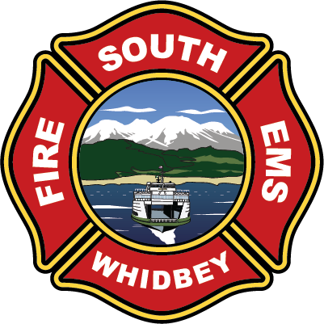
,.
South Whidbey Fire / EMS
5579 Bayview Road Langley, WA 98260
(360) 321-1533 Fax (360) 321-9385 www.swfe.org

Public Meeting
Wednesday, October 29, 2025 at 5:30pm
Minutes
Join Zoom Meeting
https://us06web.zoom.us/j/2208026387?pwd=WWNSR3JscUhZK3ZHU3JOV05ZOHF1UT09&omn=87987710600
Meeting ID: 220 802 6387
Passcode: 926342
One tap mobile
+12532158782,,2208026387#,,,,*926342# US (Tacoma)
+12532050468,,2208026387#,,,,*926342# US

Attendance: Chief Nick Walsh, Commissioner Noblet, Commissioner Erickson.
Audience: Terry Ney, Mary Kaye Johansen, Katherine Utnik, Terra Anderson, Tom Buxton, Lt. Lund, Lt. Kalahiki,
FF Chavo

- Call to Order
Commissioner Noblet called the public meeting to order at 5:30pm.
- Approval of Agenda
Commissioner Erickson motions to approve the agenda. Commissioner Noblet seconded. Motion passed unanimously.
- Presentation of Strategic Plan
Chief Walsh prepared a presentation along with handouts of the SWFE Strategic Plan 2026-2030.
There was open dialogue with audience members who shared their input and comments on the plan for our district.

- Resume Board Panel
Commissioner Noblet resumed the panel after some discussion with members of the community. Commissioner Erickson thanked the audience for coming to the meeting and giving their input. Commissioner Noblet spoke on the importance of being prepared in an emergency and he too, expressed his thanks for their participation and attendance.

- Adjourn
Commissioner Noblet adjourned the public meeting at 5:50pm.

