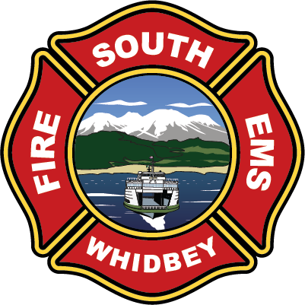
South Whidbey Fire / EMS
5579 Bayview Road □ Langley, WA 98260
(360) 321-1533 □ Fax (360) 321-9385 □ www.swfe.org

Expenditure Approval Document
Date of Approval: May14, 2026
Warrants Approved from April 1 – April 30, 2026

I, the undersigned, do hereby certify under penalty of perjury that the materials have been furnished, the services rendered, or the labor performed as described herein, that any advance payment is due and payable according to a contract or is available as an option for full or partial fulfillment of a contractual obligation and that the claim is a just, due and unpaid obligation against South Whidbey Fire/EMS, and that I am authorized to authenticate and certify to said claim.

Mary Kaye Johansen, Finance Officer Nick Walsh, Fire Chief

Michael W. Noblet, Commissioner Savanah Erickson, Commissioner

Jim Towers, Chairman

Serving the communities of Bayview - Clinton - Freeland - Langley - Maxwelton – Saratoga
Our mission: “Mission: To protect lives, serve with compassion, respond with excellence”.”

