 CHIEFS REPORT

September 2024

**CALL VOLUME REPORTS**

|  |  |  |  |  |  |  |  |  |
| --- | --- | --- | --- | --- | --- | --- | --- | --- |
| year | 2017 | 2018 | 2019 | 2020 | 2021 | 2022 | 2023 | 2024 |
| volume | 210 | 224 | 212 | 215 | 238 | 221 | 233 | 241 |

|  |  |  |  |  |  |  |  |  |  |  |  |
| --- | --- | --- | --- | --- | --- | --- | --- | --- | --- | --- | --- |
| Jan | Feb | Mar | Apr | May | Jun | Jul | Aug | Sept | Oct | Nov | Dec |
| 251 | 200 | 244 | 214 | 217 | 289 | 244 | 270 |  |  |  |  |

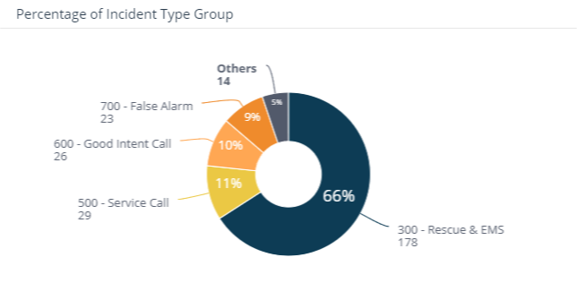

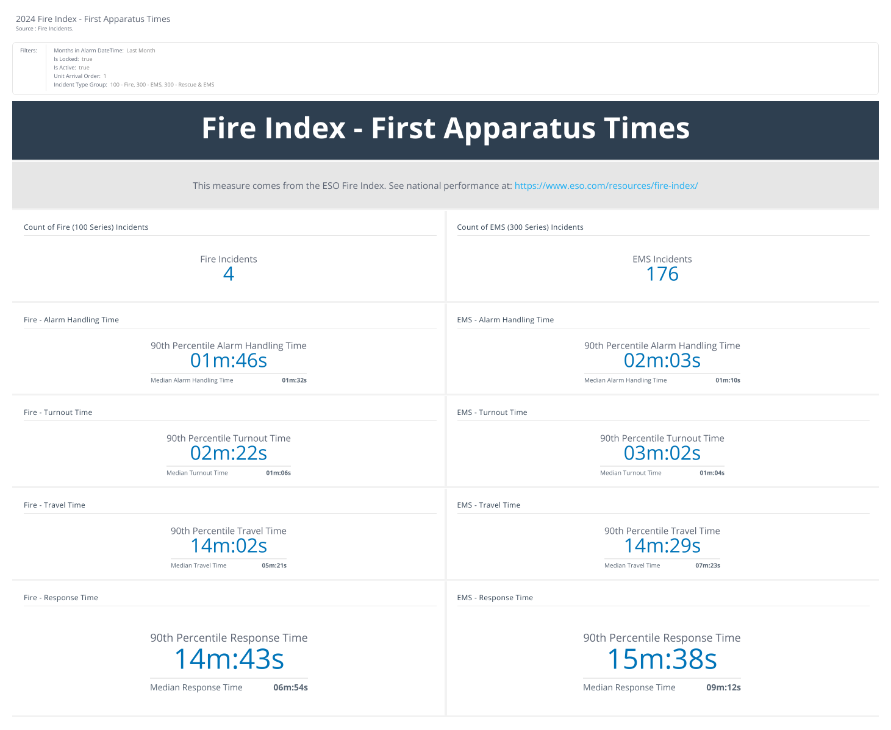

**STAFFING REPORTS**

Fourth seat coverage was at 59% (down from 80%)

Fifth seat coverage was at 15% (down from 37%)

Although the seat coverage was slightly down, our overall participation was

**RECRUITMENT AND RETENTION**

New volunteers in process

1- New volunteer members ready for approval

1- Applications in process

**UPCOMING EVENTS**

All District Meeting – September 19th

Strategic Planning Meeting – September 14th