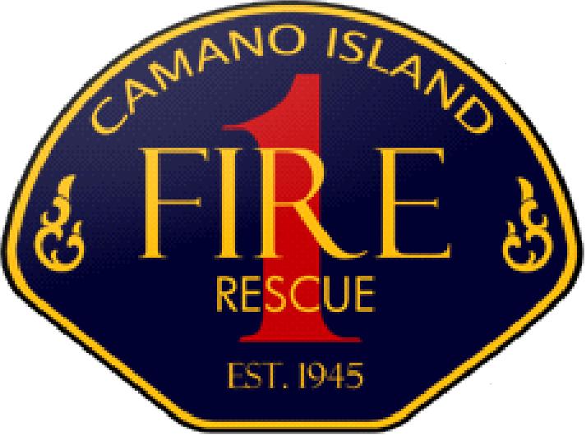 | 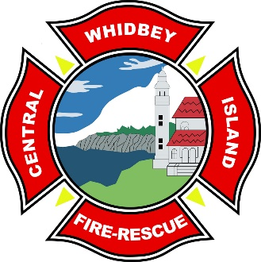 | 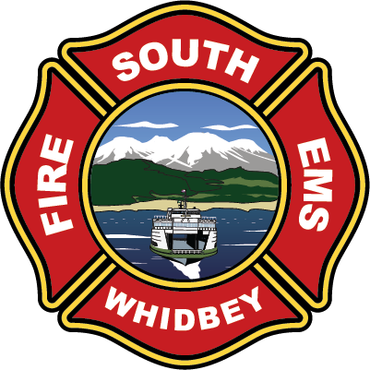 | 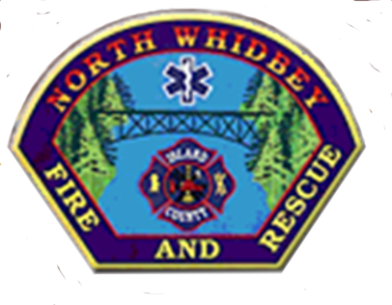

ISLAND COUNTY BOARD OF
FIRE COMMISSIONERS MEETING
Minutes- Approved
Wednesday, November 6, 2024 at 5:30 PM 1164 Race Rd., Coupeville WA 98239
Join Zoom Meeting
https://us02web.zoom.us/j/89342056699

Attendees: Commissioner Savanah Erickson, Commissioner Mike Noblet, Commissioner Jim Towers, Chief Nick Walsh, Shari Schroeder, Commissioner Koorn, Commissioner Smith, Commissioner Miller, Chief Levon Yengoyan, Chief Jerry Helm, Commissioner Paul Williams, Commissioner Kim Williams, Commissioner Paul Foster, Commissioner Cheryl Engel, Commissioner Steve Hutchinson, Chief Chris Swiger, James Meek, Brandon and Maci Murphy, Natasha Spydell, Cathy Niiro, Commissioner Paul Messner, John Lange, Chris Tumblin, Vicki Lange.

Commissioner Erickson called the Island County Board of Fire Commissioners meeting to order at 5:32pm.

Pledge of Allegiance
Consensus Approval of the Agenda
Introductions
Topics of Discussion
- Housing – Lack of affordable housing on the island. Cost of living vs. wages impacts retention and creates high turnover.
- Permit Process- https://www.islandcounty2045.com/compplan provides information for land use and building permit requirements. Pre-application conference available for assistance when planning project. Time frames of 60-90 days for land use permit and 8-10 weeks for building permit. There is an option to contract out to speed up process if necessary.
- Whidbey Health – Local union Vice President with 49 paramedic members inquired about future intentions of Fire Stations and providing paramedic services on scene. There are no plans for ALS programs. Continue to develop a practice of transparency and frequent communication with a partnership and commitment to team work for our communities.
- Fire Marshall- Position currently held through Island County Sherriff’s Dept. but a standalone office for a Fire Marshall in Island County is preferred. Fire Chief’s to present key points to Fire Commissioners and they in turn will propose the necessity for Island County Commissioners to address.

A proposal was made that Island County Fire Commissioners meet every 6-12 months for continued transparency and communication.

Commissioner Erickson called the Island County Fire Commissioners meeting to and end at 7:00pm.

